20131003
Here esxist files about kickstart. These files made by Altxey Terentyev.
We can find root password here for servers made by this kickstart technologies.

N:\soft4\Linux\RedHat\tcs_ks

20131118
This text was taken from document “20131118 Install and configure 8 green plum servers in ds-gp-prod”.

From ds-gp-tst-sdw6.
[root@sdw6 ~]# cat ~/anaconda-ks.cfg
# Kickstart file automatically generated by anaconda.

#version=DEVEL
install
cdrom
lang en_US.UTF-8
keyboard us
network --onboot no --device eth0 --noipv4 --noipv6
network --onboot no --device eth1 --noipv4 --noipv6
network --onboot no --device eth2 --noipv4 --noipv6
network --onboot no --device eth3 --noipv4 --noipv6
network --onboot no --device eth4 --noipv4 --noipv6
network --onboot no --device eth5 --noipv4 --noipv6
rootpw --iscrypted $6$yI4TYDyIsCMdjlF7$CRj8Ic.l4Tyt2cBPaA1R3GM5sO73NzvEdJ.QTEOxKA9qm79TgokCVU99uFTYB06SG16Amo3AGekiI24eFQGlO.
firewall --service=ssh
authconfig --enableshadow --passalgo=sha512
selinux --enforcing
timezone --utc Europe/Moscow
bootloader --location=mbr --driveorder=sda,sdb --append=" rhgb crashkernel=auto quiet"
# The following is the partition information you requested
# Note that any partitions you deleted are not expressed
# here so unless you clear all partitions first, this is
# not guaranteed to work
#clearpart --none

#part /boot --fstype=ext4 --size=1024
#part /data1 --fstype=xfs --size=3362984
#part /work11 --fstype=xfs --size=384000
#part /work21 --fstype=xfs --size=128000
#part / --fstype=ext4 --size=48128

#part /data2 --fstype=xfs --size=3362984
#part /work12 --fstype=xfs --size=384000
#part swap --size=131071
#part /work22 --fstype=xfs --size=128000

repo --name="Red Hat Enterprise Linux" --baseurl=cdrom:sr0 --cost=100

%packages
@base
@client-mgmt-tools
@console-internet
@core
@debugging
@directory-client
@hardware-monitoring
@java-platform
@large-systems
@network-file-system-client
@performance
@perl-runtime
@server-platform
@server-policy
pax
python-dmidecode
oddjob
sgpio
certmonger
pam_krb5
krb5-workstation
perl-DBD-SQLite
%end[root@sdw6 ~]#

From ds-gp-prod-sdw1
[root@sdw1 ~]# cat ~/anaconda-ks.cfg
# Kickstart file automatically generated by anaconda.

#version=DEVEL
install
cdrom
lang en_US.UTF-8
keyboard us
network --onboot no --device eth0 --noipv4 --noipv6
network --onboot no --device eth1 --noipv4 --noipv6
network --onboot no --device eth2 --noipv4 --noipv6
network --onboot no --device eth3 --noipv4 --noipv6
network --onboot no --device eth4 --noipv4 --noipv6
network --onboot no --device eth5 --noipv4 --noipv6
rootpw --iscrypted $6$zMqSV0IwhUMBglhc$.vdABcIf5JTXQ7O4i6K.VXJ86gE9Ja13GcI8rL35dGr0vihrgpRHv3FM0yk4MSB4Nk9s0JtDYiiHidPoK3gWF.
firewall --service=ssh
authconfig --enableshadow --passalgo=sha512
selinux --enforcing
timezone --utc Europe/Moscow
bootloader --location=mbr --driveorder=sda,sdb --append=" rhgb crashkernel=auto quiet"
# The following is the partition information you requested
# Note that any partitions you deleted are not expressed
# here so unless you clear all partitions first, this is
# not guaranteed to work
#clearpart --none

#part /boot --fstype=ext4 --grow --maxsize=1008 --size=1
#part / --fstype=ext4 --size=47373
#part /data1 --fstype=xfs --size=3558262
#part /work1 --fstype=xfs --size=311848

#part /data2 --fstype=xfs --size=3558262
#part /work2 --fstype=xfs --size=311848
#part swap --grow --size=200

repo --name="Red Hat Enterprise Linux" --baseurl=cdrom:sr0 --cost=100

%packages
@base
@client-mgmt-tools
@console-internet
@core
@debugging
@directory-client
@hardware-monitoring
@java-platform
@large-systems
@network-file-system-client
@performance
@perl-runtime
@server-platform
@server-policy
pax
python-dmidecode
oddjob
sgpio
certmonger
pam_krb5
krb5-workstation
perl-DBD-SQLite
%end[root@sdw1 ~]#

[support@centos00 greenplum]$ mkfs.vfat -C "floppy.img" 1440
mkfs.vfat 3.0.9 (31 Jan 2010)
[support@centos00 greenplum]$

[root@centos00 tmp]# sudo mount -o loop -t vfat /home/support/mnt/share/greenplum/floppy.img /mnt/floppy
You have new mail in /var/spool/mail/root
[root@centos00 tmp]#

[root@centos00 tmp]# cp /home/support/mnt/share/greenplum/kickstart-greenplum.cfg /mnt/floppy/
[root@centos00 tmp]#

[root@centos00 tmp]# df -h
Filesystem Size Used Avail Use% Mounted on
/dev/mapper/vg_centos00-lv_root
16G 3.5G 12G 24% /
tmpfs 1.9G 296K 1.9G 1% /dev/shm
/dev/sda1 485M 38M 423M 9% /boot
share 320G 173G 148G 54% /home/support/mnt/share
share 320G 173G 148G 54% /media/sf_share
share 320G 173G 148G 54% /home/support/mnt/share
/home/support/mnt/share/greenplum/floppy.img
1.4M 2.0K 1.4M 1% /mnt/floppy
[root@centos00 tmp]# umount /mnt/floppy
[root@centos00 tmp]#

https://access.redhat.com/site/documentation/ru-RU/Red_Hat_Enterprise_Linux/6/html/Installation_Guide/sn-automating-installation.html

28.4. Автоматизация установки
Файл кикстарта определяет настройки для установки, которые пользователь обычно вводит вручную. Система установки сможет прочитать этот файл и выполнить установку автоматически без дальнейшего вмешательства со стороны пользователя.
Запись anaconda-ks.cfg при установке
Процесс установки Red Hat Enterprise Linux автоматически сохраняет настройки установки в файл /root/anaconda-ks.cfg, который можно впоследствии использовать для повторной установки с идентичными настройками или скопировать с целью последующей модификации параметров.
Кикстарт-установка и Firstboot
Если в процессе установки не была установлена система X Window и не включены возможности графической авторизации, Firstboot не будет запущен. В этом случае добавьте параметр user в файл кикстарта, прежде чем приступить к установке других систем (см. Раздел 32.4, «Параметры кикстарта»), или авторизуйтесь как root в виртуальной консоли и добавьте пользователей вручную с помощью adduser.
Red Hat Enterprise Linux включает в свой состав графическое приложение для создания и редактирования кикстарт-файлов путем выбора требуемых параметров. Оно устанавливается в составе пакета system-config-kickstart. Чтобы запустить редактор, выберите Приложения → Системные → Kickstart.
В файлах кикстарта параметры установки перечислены в текстовом формате, в каждой строке по параметру. Такой формат позволяет изменять файлы в текстовом редакторе и создавать сценарии и приложения, создающие собственные кикстарт-файлы для ваших систем.
Чтобы автоматизировать процесс установки, используйте параметр ks для указания имени и местоположения файла кикстарта:
linux ks=location/kickstart-file.cfg
Допускается использовать файлы, расположенные на съемных носителях, жестком диске или сервере в сети (см. Таблица 28.2, «Путь к файлу кикстарта»).
Таблица 28.2. Путь к файлу кикстарта
Источник параметр
DVD ks=cdrom:/каталог/ks.cfg
Жесткий диск ks=hd:/устройство/каталог/ks.cfg
Другое устройство ks=файл:/устройство/каталог/ks.cfg
HTTP-сервер ks=http://server.mydomain.com/каталог/ks.cfg
HTTPS-сервер ks=https://server.mydomain.com/каталог/ks.cfg
FTP-сервер ks=ftp://server.mydomain.com/каталог/ks.cfg
NFS-сервер ks=nfs:server.mydomain.com:/каталог/ks.cfg

Чтобы получить файл кикстарта из сценария или приложения на веб-сервере, укажите URL приложения в параметре ks=. Если добавить параметр kssendmac, то запрос также отправит HTTP-заголовки веб-приложению. Ваше приложение может использовать эти заголовки для идентификации компьютера. Следующая строка отправит запрос с заголовками сценарию http://server.mydomain.com/kickstart.cgi:
linux ks=http://server.mydomain.com/kickstart.cgi kssendmac

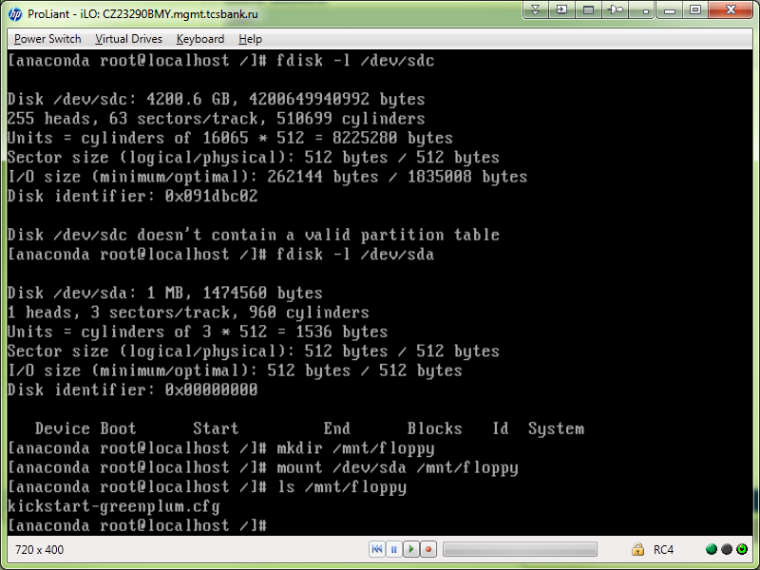

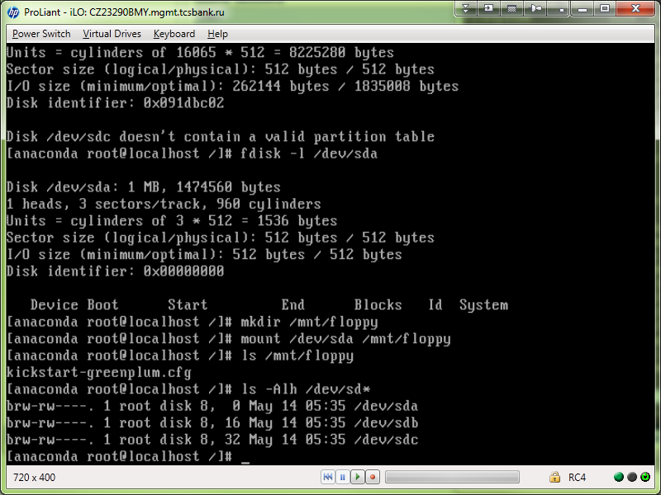

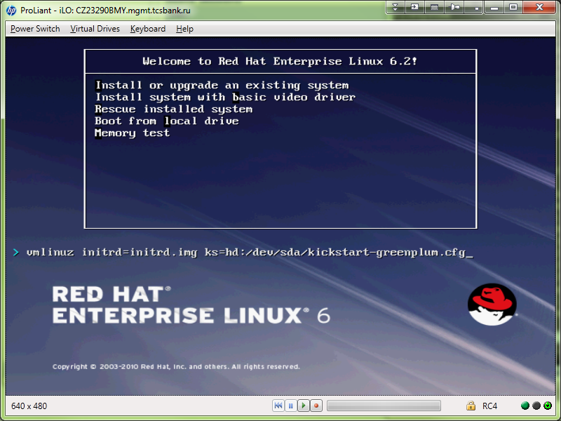

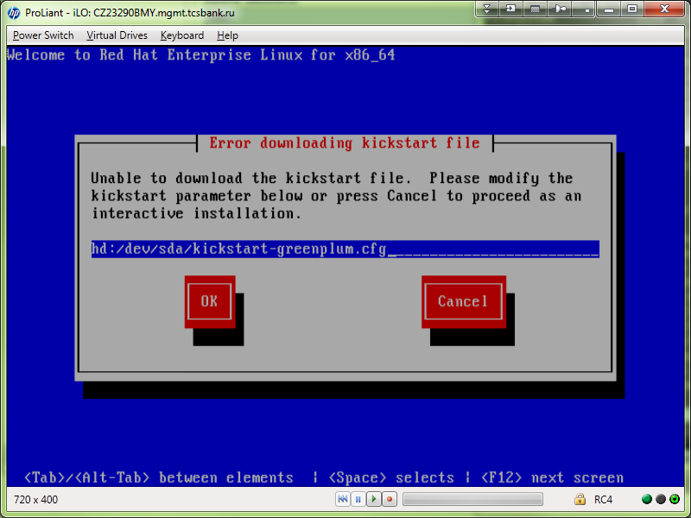

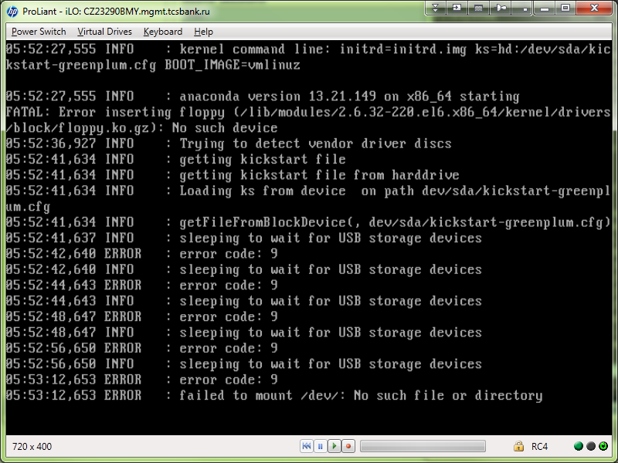

[root@centos00 tmp]# sudo mount -o loop -t vfat /home/support/mnt/share/greenplum/floppy.img /mnt/floppy
[root@centos00 tmp]# ls /mnt/floppy/
[root@centos00 tmp]# cp /home/support/mnt/share/greenplum/kickstart-greenplum.cfg /mnt/floppy/ks.cfg
[root@centos00 tmp]# umount /mnt/floppy
[root@centos00 tmp]#

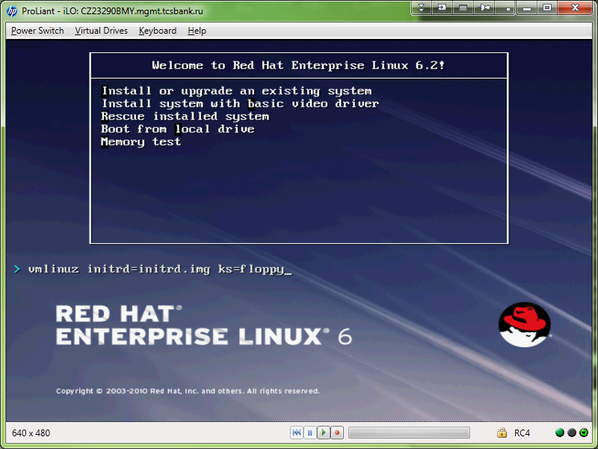

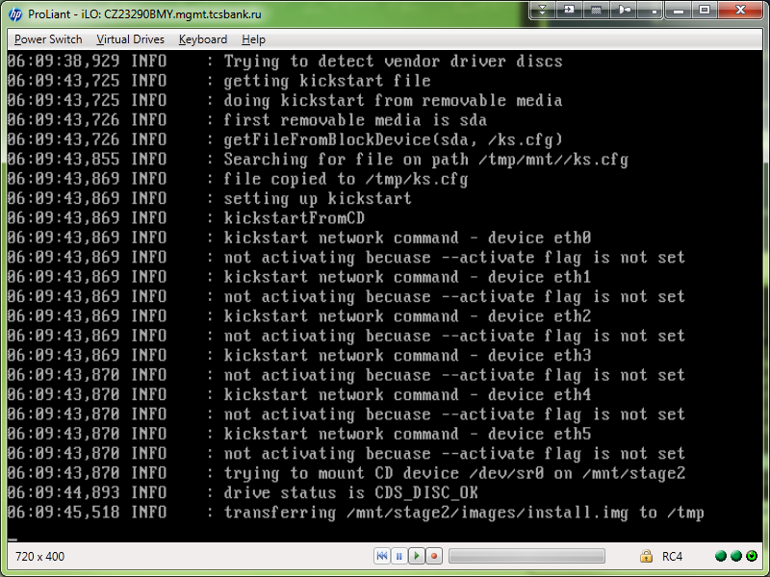

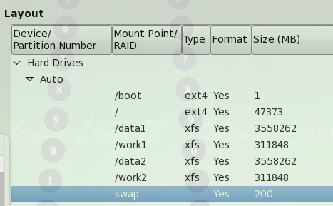

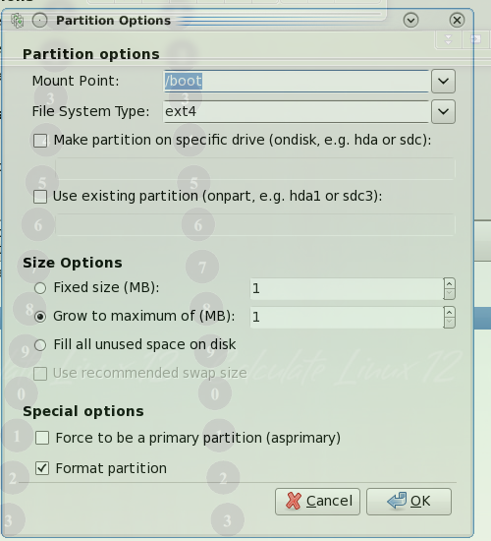

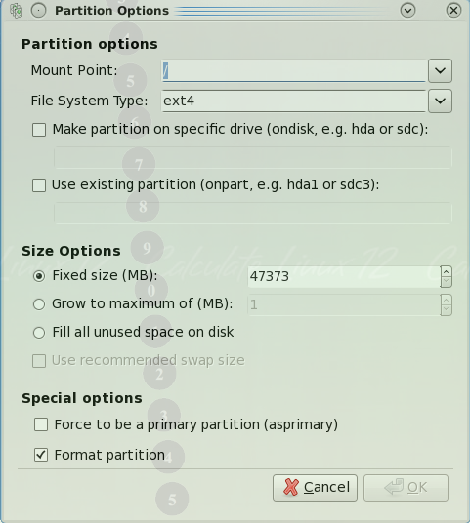

[support@centos00 greenplum]$ cat /home/support/mnt/share/greenplum/20131118-1840.kickstart.greenplum.cfg
#platform=x86, AMD64, or Intel EM64T
#version=DEVEL
# Firewall configuration
firewall --disabled
# Install OS instead of upgrade
install
# Use CDROM installation media
cdrom
repo --name="Red Hat Enterprise Linux" --baseurl=cdrom:sr0 --cost=100
# Root password
rootpw --iscrypted $1$kltsgn4j$LmQ2cv1TrCbUWvIcDmJLS.
# System authorization information
auth --useshadow --passalgo=sha512
# Use graphical install
graphical
firstboot --disable
# System keyboard
keyboard us
# System language
lang en_US
# SELinux configuration
selinux --disabled
# Installation logging level
logging --level=info

# System timezone
timezone Europe/Moscow
# Network information
network --bootproto=dhcp --device=eth0 --onboot=on
network --bootproto=dhcp --device=eth1 --onboot=on
network --bootproto=dhcp --device=eth2 --onboot=on
network --bootproto=dhcp --device=eth3 --onboot=on
network --bootproto=dhcp --device=eth4 --onboot=on
network --bootproto=dhcp --device=eth5 --onboot=on
# System bootloader configuration
bootloader --append="rhgb crashkernel=auto quiet" --location=mbr --driveorder="sda,sdb"
# Partition clearing information
clearpart --all
# Disk partitioning information
part /boot --asprimary --fstype="ext4" --ondisk=/dev/sda --size=200
part / --asprimary --fstype="ext4" --ondisk=/dev/sda --size=47373

%packages
@base
@client-mgmt-tools
@console-internet
@core
@debugging
@directory-client
@hardware-monitoring
@java-platform
@large-systems
@network-file-system-client
@performance
@perl-runtime
@server-platform
@server-policy
certmonger
krb5-workstation
oddjob
pam_krb5
pax
perl-DBD-SQLite
python-dmidecode
sgpio

%end
[support@centos00 greenplum]$

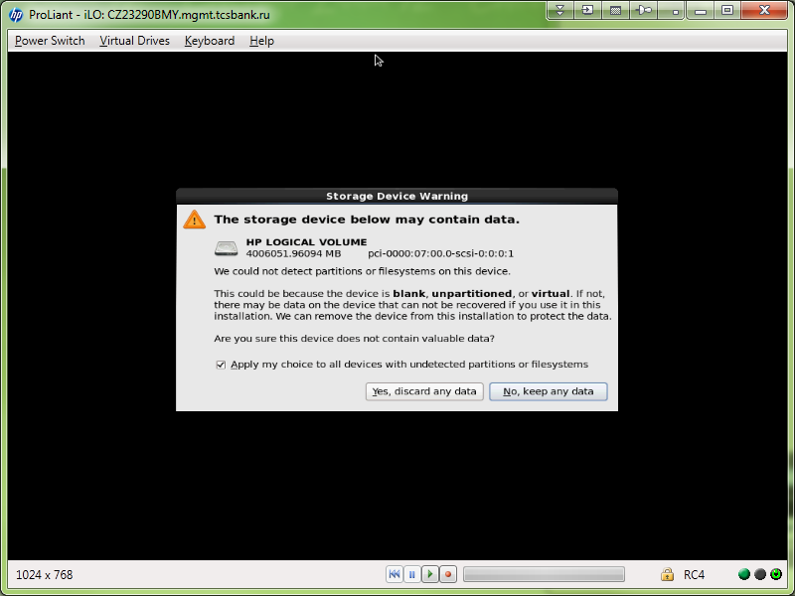

Drive /dev/sda used for floppy drive.

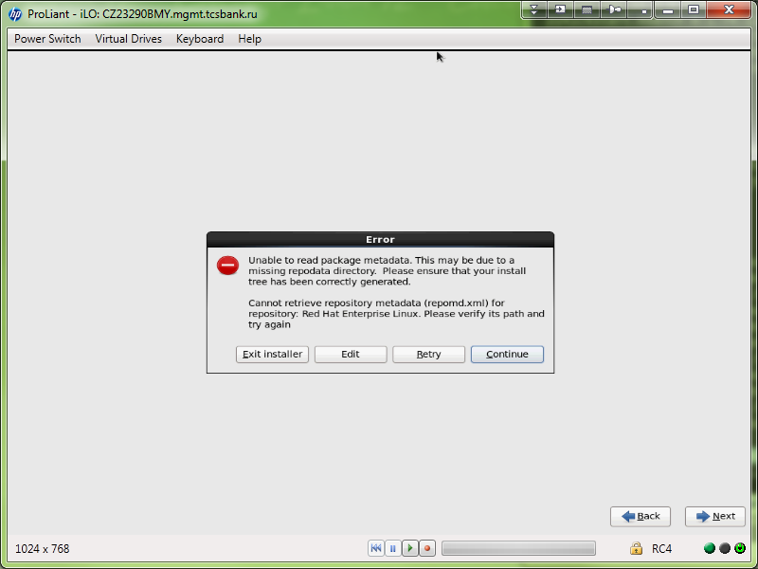

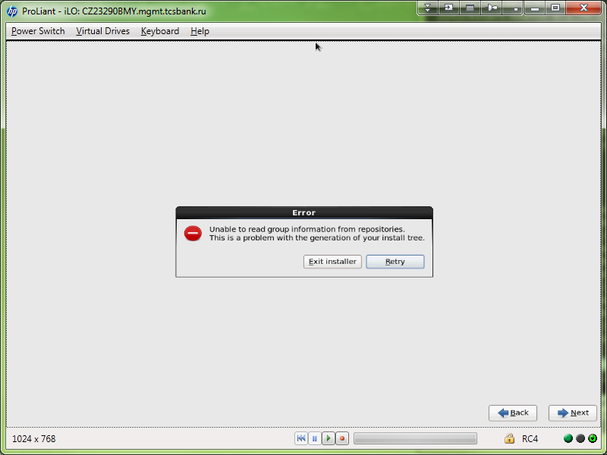

https://access.redhat.com/site/solutions/40539

[RHEL 6] Unable to install from kickstart using DVD image as installation source/repository
Updated 22.02.2011
Rate
0
No votes yet
Available Translations
English
Verified
This solution has been verified to work by Red Hat Customers and Support Engineers for the specified product version(s).
This solution is part of Red Hat's fast-track publication program, providing a huge library of solutions that Red Hat engineers have created while supporting our customers. To give you the knowledge you need the instant it becomes available, these articles may be presented in a raw and unedited form.

Issue

At least one package can't be installed from kickstart using x86_64 DVD image RHEL6.0-20100909.1-Server-x86_64-DVD1.iso as an installation source
The package also can't be installed with yum using the DVD contents as a repository
Environment

Red Hat Enterprise Linux (RHEL) 6
Resolution

For kickstart installations, add the 'repo' directive for each AddOn repository that is needed (HighAvailability, LoadBalancer, etc).
For installing packages from the DVD using yum, add a yum repository configuration for each needed AddOn.

How to add a local yum repository, please follow below steps.

Mount RHEL 6 ISO to /media/rhel6

# mount -o loop RHEL6.0-20101111.0-Server-x86_64-DVD.iso /media/rhel6
Copy media.repo file from the RHEL 6 ISO to /etc/yum.repos.d/

# cp /media/media.repo /etc/yum.repos.d/rhel6.repo
Configure the repo file to point to the /media/rhel6

# vi /etc/yum.repos.d/rhel6.repo
add following line

baseurl=file:///media/rhel6/Server
If you want to configure repository for HighAvailability , LoadBalancer , ResilientStorage , ScalableFileSystem then you can add following lines in rhel6.repo file

[dvd-HighAvailability]
mediaid=1289489697.332694
name=DVD for RHEL6 - HighAvailability
baseurl=file:///media/rhel6/HighAvailability
enabled=1
gpgcheck=0

[dvd-LoadBalancer]
mediaid=1289489697.332694
name=DVD for RHEL6 - LoadBalancer
baseurl=file:///media/rhel6/LoadBalancer
enabled=1
gpgcheck=0

[dvd-ResilientStorage]
mediaid=1289489697.332694
name=DVD for RHEL6 - ResilientStorage
baseurl=file:///media/rhel6/ResilientStorage
enabled=1
gpgcheck=0

[dvd-ScalableFileSystem]
mediaid=1289489697.332694
name=DVD for RHEL6 - ScalableFileSystem
baseurl=file:///media/rhel6/ScalableFileSystem
enabled=1
gpgcheck=0
Root Cause

In Red Hat Enterprise Linux 5, each AddOn on the DVD had its own Packages/ directory. In Red Hat Enterprise Linux 6 the structure switched to a single Packages/ directory that is symlinked from the various subdirectories. Repodata is used to distinguish which RPMs belong to the base product and which belong to each of the AddOns.The primary motivation for this change was to eliminiate package duplication. There were already several RPMs that appeared more than once and the old setup would have caused them to get included multiple times on the DVD. Additionally, having a single Packages/ directory allows for more future flexibility.

https://bugzilla.redhat.com/show_bug.cgi?id=948713

RHEL6.3 DVD: Unable to read group information from repositories.

https://access.redhat.com/site/documentation/en-US/Red_Hat_Enterprise_Linux/6/html/Installation_Guide/s1-kickstart2-file.html

[root@centos00 share]# mount -o loop /media/sf_share/redhat/Red\ Hat\ Enterprise\ Linux\ 6\ Server\ \(x86-64\)/rhel-server-6.2-x86_64-dvd.iso /mnt/iso
[root@centos00 share]#
[root@centos00 mnt]# cp -r /mnt/iso/* /media/sf_share/greenplum/rhel-server-6.2-x86_64-dvd-kickstart-edition/

[root@centos00 mnt]# cp ~support/work/20131118/20131121-1701.kickstart.greenplum.cfg /media/sf_share/greenplum/rhel-server-6.2-x86_64-dvd-kickstart-edition/ks.cfg
[root@centos00 mnt]#

[root@centos00 mnt]# cd /media/sf_share/greenplum/rhel-server-6.2-x86_64-dvd-kickstart-edition/
[root@centos00 rhel-server-6.2-x86_64-dvd-kickstart-edition]#

If we don’t put dot symbol into end of the line. We will get this trouble.
[root@centos00 rhel-server-6.2-x86_64-dvd-kickstart-edition]# mkisofs -r -o /tmp/rhel-server-6.2-x86_64-dvd-kickstart-edition.iso
I: -input-charset not specified, using utf-8 (detected in locale settings)
genisoimage: Missing pathspec.
Usage: genisoimage [options] -o file directory ...

Use genisoimage -help
to get a list of valid options.

Report problems to debburn-devel@lists.alioth.debian.org.
[root@centos00 rhel-server-6.2-x86_64-dvd-kickstart-edition]#

[root@centos00 rhel-server-6.2-x86_64-dvd-kickstart-edition]# mkisofs -r -o /tmp/rhel-server-6.2-x86_64-dvd-kickstart-edition.iso .
I: -input-charset not specified, using utf-8 (detected in locale settings)
Using RPM_G000.;1 for /RPM-GPG-KEY-redhat-release (RPM-GPG-KEY-redhat-beta)
Using RELEA000.HTM;1 for /RELEASE-NOTES-zh-TW.html (RELEASE-NOTES-zh-CN.html)
Using RELEA001.HTM;1 for /RELEASE-NOTES-zh-CN.html (RELEASE-NOTES-te-IN.html)
Using RELEA002.HTM;1 for /RELEASE-NOTES-te-IN.html (RELEASE-NOTES-ta-IN.html)
…
99.57% done, estimate finish Thu Nov 21 17:25:27 2013
99.86% done, estimate finish Thu Nov 21 17:25:28 2013
Total translation table size: 0
Total rockridge attributes bytes: 410309
Total directory bytes: 632832
Path table size(bytes): 270
Max brk space used 33a000
1752502 extents written (3422 MB)
[root@centos00 rhel-server-6.2-x86_64-dvd-kickstart-edition]#

[root@centos00 rhel-server-6.2-x86_64-dvd-kickstart-edition]# mv /tmp/rhel-server-6.2-x86_64-dvd-kickstart-edition.iso /media/sf_share/greenplum/
[root@centos00 rhel-server-6.2-x86_64-dvd-kickstart-edition]#

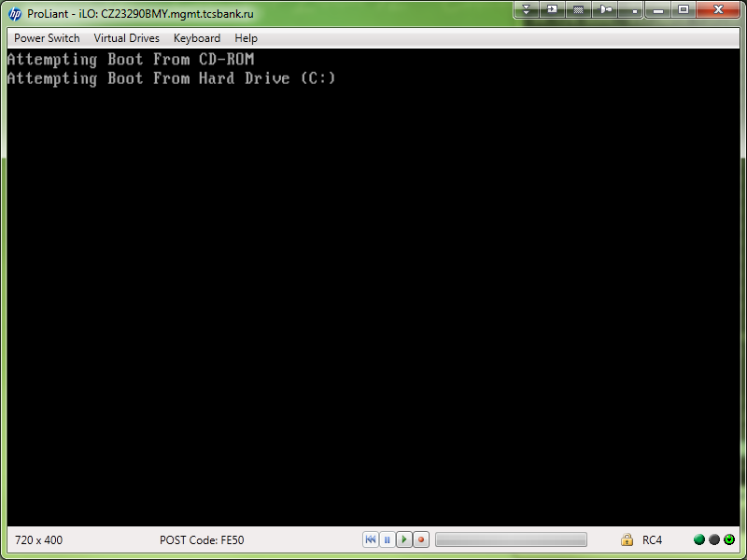

https://access.redhat.com/site/documentation/en-US/Red_Hat_Enterprise_Linux/6/html/Installation_Guide/s1-kickstart2-startinginstall.html

Boot CD-ROM
If the kickstart file is on a boot CD-ROM as described in Section 32.8.1, “Creating Kickstart Boot Media”, insert the CD-ROM into the system, boot the system, and enter the following command at the boot: prompt (where ks.cfg is the name of the kickstart file):
linux ks=cdrom:/ks.cfg

https://access.redhat.com/site/solutions/60959

[root@centos00 rhel-server-6.2-x86_64-dvd-kickstart-edition]# mkisofs -b isolinux/isolinux.bin -c isolinux/boot.cat -no-emul-boot -boot-load-size 4 -boot-info-table -J -R -V disks -o /media/sf_share/greenplum/rhel-server-6.2-x86_64-dvd-kickstart-edition.iso .

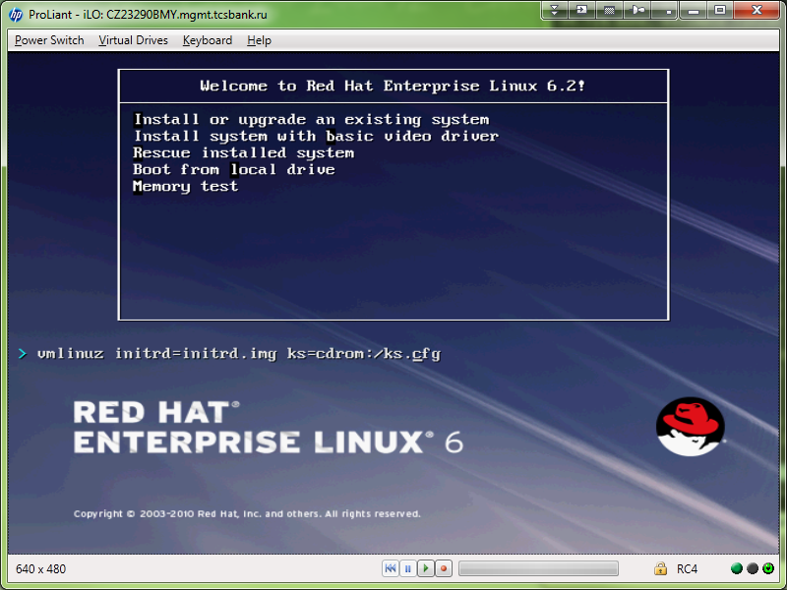

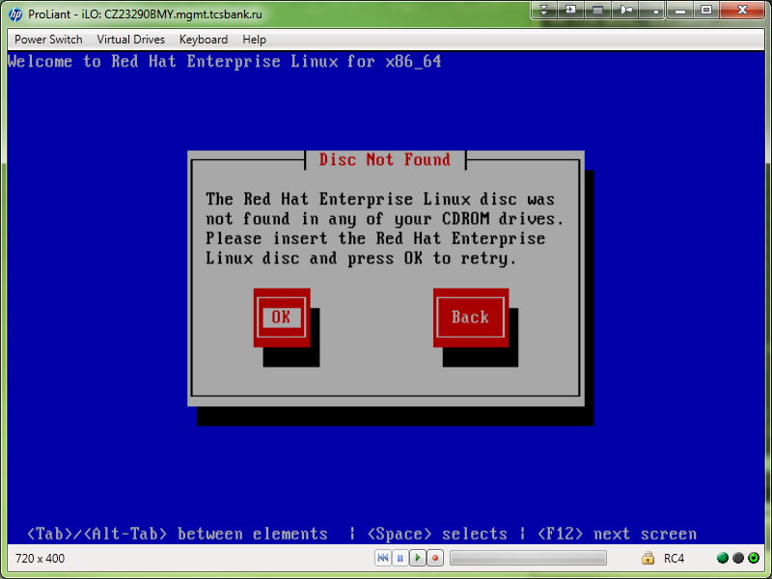

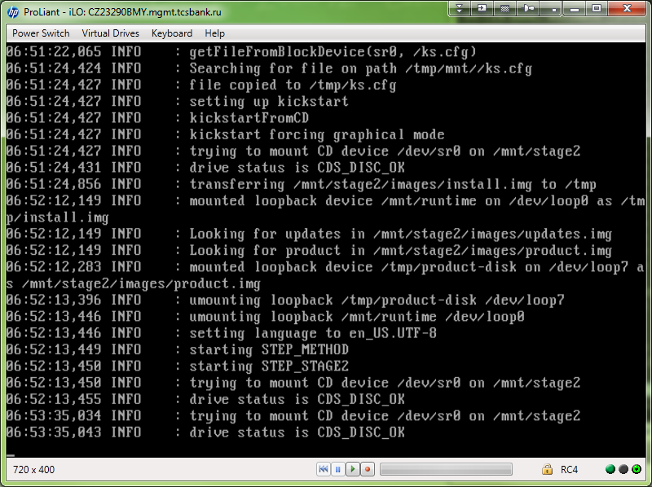

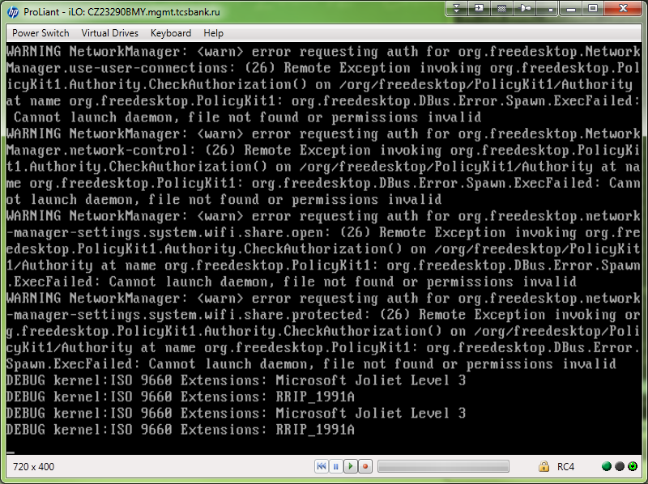

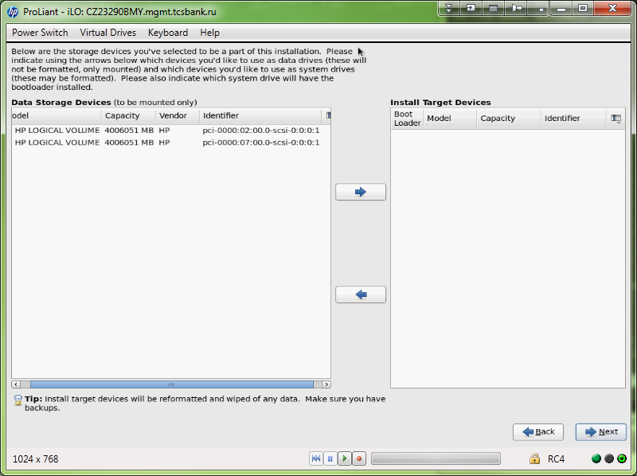

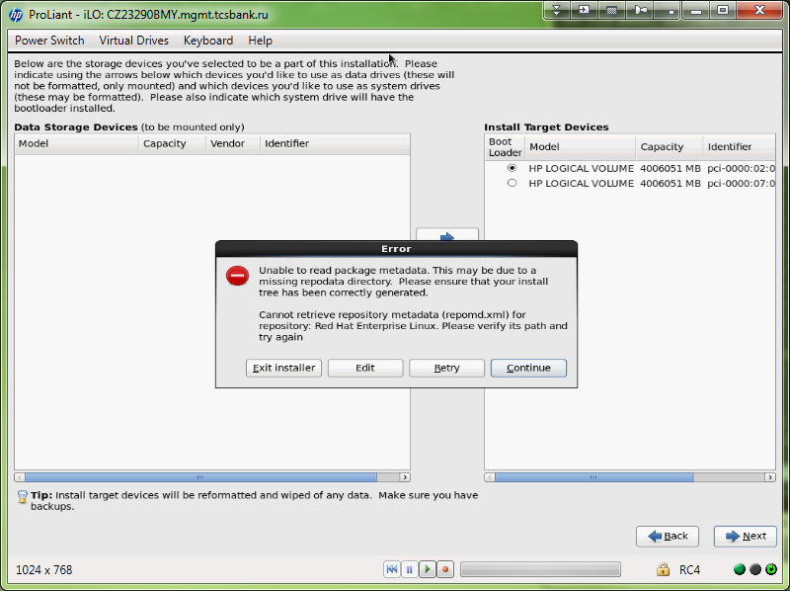

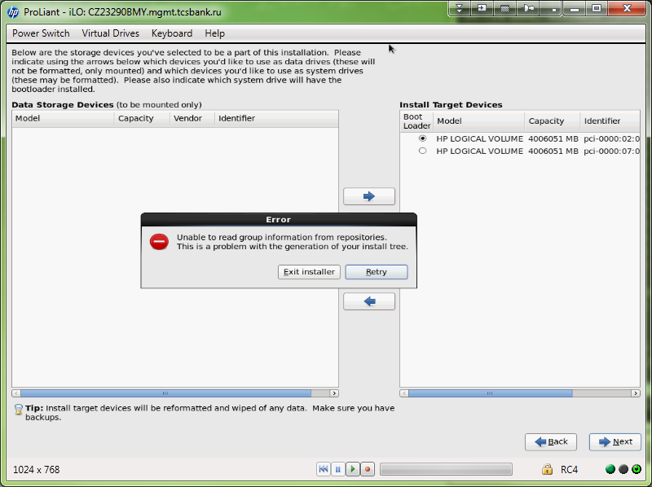

20140128

[support@centos00 kickstart]$ mkfs.vfat -C "floppy.img" 1440
mkfs.vfat 3.0.9 (31 Jan 2010)
[support@centos00 kickstart]$
[support@centos00 kickstart]$ sudo mount -o loop -t vfat /home/support/mnt/share/greenplum/kickstart/floppy.img /mnt/floppy
[support@centos00 kickstart]$
[support@centos00 kickstart]$ sudo cp /home/support/mnt/share/greenplum/kickstart/20140128-1706.kickstart.test.cfg /mnt/floppy/ks.cfg
[support@centos00 kickstart]$
[support@centos00 kickstart]$ sudo umount /mnt/floppy
[support@centos00 kickstart]$

[root@centos00 tmp]# sudo mount -o loop -t vfat /home/support/mnt/share/greenplum/floppy.img /mnt/floppy
[root@centos00 tmp]# ls /mnt/floppy/
[root@centos00 tmp]# cp /home/support/mnt/share/greenplum/kickstart-greenplum.cfg /mnt/floppy/ks.cfg
[root@centos00 tmp]# umount /mnt/floppy
[root@centos00 tmp]#

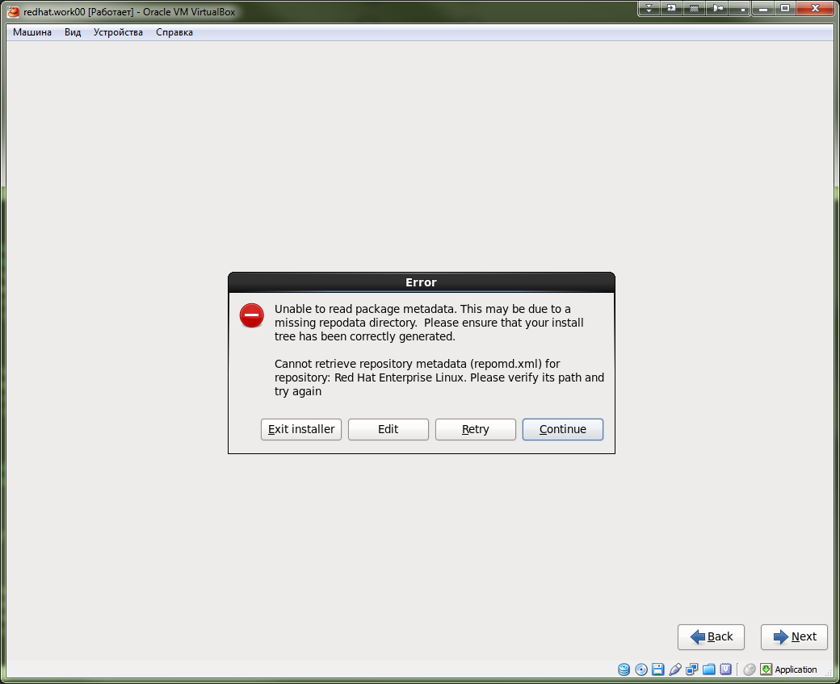

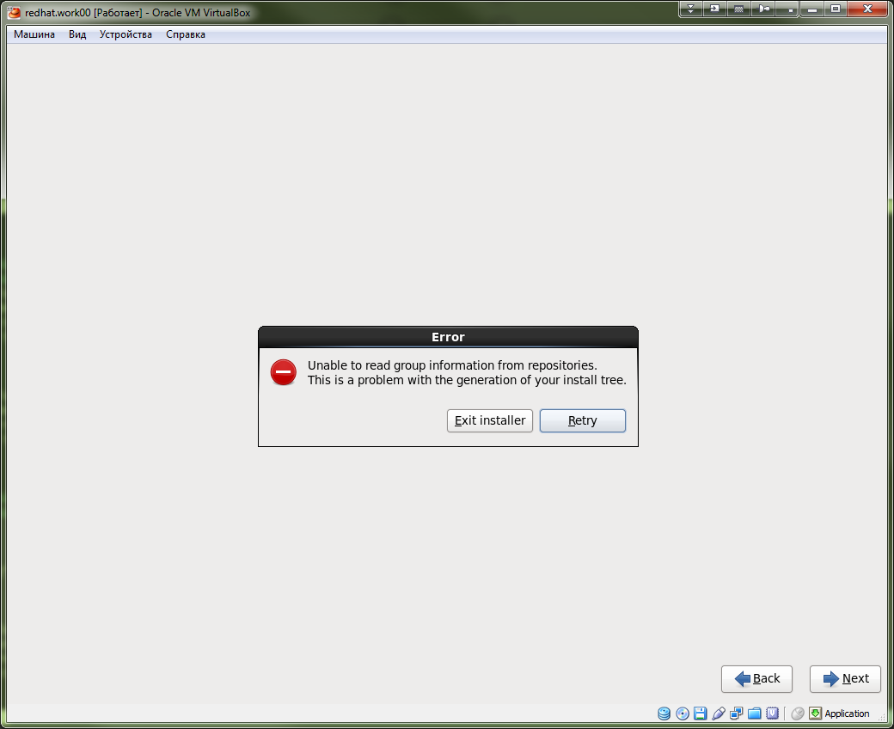

Hello Sr.

Please help us with usage of kickstart (anakonda-ks.cfg) method for server deployment.
Installation procedure was interrupted with error message and it prevents deploy the server.

For installation I have used distributive image file rhel-server-6.4-x86_64-dvd.iso.

Several first times I have used physical HP servers like models ProLiant DL380 G7 or ProLiant DL380p Gen8.
But full cycle of reboot for server takes too long time. And for testing now I use VirtualBox software installed on my ms windows workstation. As I understand it must not reflect on success of deployment operation.

When I had used physical servers, I have mounted iso-image of RedHat distributive as a CD-ROM device via iLO facilities. And In same time I mounted floppy image img-file as a floppy device via iLO facilities too.

I had done same when I have used VirtualBox for guest virtual machine.

If I’m not wrong this is the simplest method of deployment via kickstart file. If you have useful advices or best practice recommendations for deployment, please share it to me too.

I found this link that shows method of usage kickstart file.
https://access.redhat.com/site/documentation/en-US/Red_Hat_Enterprise_Linux/6/html/Installation_Guide/sn-automating-installation.html

As a kickstart-file I have used this file.
[support@centos00 kickstart]$ cat 20140128-1706.kickstart.test.cfg
#platform=x86, AMD64, or Intel EM64T
#version=DEVEL
# Firewall configuration
firewall --disabled
# Install OS instead of upgrade
install
# Use CDROM installation media
cdrom
repo --name="Red Hat Enterprise Linux" --baseurl=cdrom:sr0 --cost=100
# Root password
rootpw --iscrypted $1$kltsgn4j$LmQ2cv1TrCbUWvIcDmJLS.
# System authorization information
auth --useshadow --passalgo=sha512
# Use graphical install
graphical
firstboot --disable
# System keyboard
keyboard us
# System language
lang en_US
# SELinux configuration
selinux --disabled
# Installation logging level
logging --level=info

# System timezone
timezone Europe/Moscow
# Network information
network --bootproto=dhcp --device=eth0 --onboot=on
# System bootloader configuration
bootloader --append="rhgb crashkernel=auto quiet" --location=mbr --driveorder="sda,sdb"
# Partition clearing information
clearpart --all
# Disk partitioning information
part /boot --asprimary --fstype="ext4" --ondisk=/dev/sda --size=200
part / --asprimary --fstype="ext4" --ondisk=/dev/sda --size=47373

%packages
@base
@client-mgmt-tools
@console-internet
@core
@debugging
@directory-client
@hardware-monitoring
@java-platform
@large-systems
@network-file-system-client
@performance
@perl-runtime
@server-platform
@server-policy
certmonger
krb5-workstation
oddjob
pam_krb5
pax
perl-DBD-SQLite
python-dmidecode
sgpio

%end
[support@centos00 kickstart]$

I used these commands to create img-image of floppy drive file.
[support@centos00 kickstart]$ mkfs.vfat -C "floppy.img" 1440
mkfs.vfat 3.0.9 (31 Jan 2010)
[support@centos00 kickstart]$
[support@centos00 kickstart]$ sudo mount -o loop -t vfat /home/support/mnt/share/greenplum/kickstart/floppy.img /mnt/floppy
[support@centos00 kickstart]$
[support@centos00 kickstart]$ sudo cp /home/support/mnt/share/greenplum/kickstart/20140128-1706.kickstart.test.cfg /mnt/floppy/ks.cfg
[support@centos00 kickstart]$
[support@centos00 kickstart]$ sudo umount /mnt/floppy
[support@centos00 kickstart]$

I have attached couple of screenshots.

-----Original Message-----
From: Red Hat Support [mailto:support@redhat.com]
Sent: Thursday, January 30, 2014 4:34 PM
To: Aleksandrov Aleksey Valerievich; Belogrud Sergey Vladimirovich
Subject: (Waiting on Customer) Case #01024962 (Please, help us with usage kickstart ks.cfg file) [ ref:00DA0000000HxWHMA0.500A000000Hmq8NIAR:ref ]

---------------------------------------
| Case Information |
---------------------------------------
https://access.redhat.com/support/cases/01024962
Case Title : Please, help us with usage kickstart ks.cfg file
Case Number : 01024962
Case Open Date : 2014-01-29 18:51:58

Most recent comment: On 2014-01-30 16:33:30, Gaikwad, Suresh commented:
"Greetings.

Welcome to Red Hat Technical Support. My name is Suresh Gaikwad and I will be assisting you during this service request.

From the case description it seems that you are trying to install Red Hat Enterprise Linux on a virtual box. For that you are creating a custom ISO file by putting the kickstart file inside the ISO image. Please correct me if I am wrong.

If you want to create a custom ISO image with inbuilt kickstart file, please refer the article which explains about "How can we create a customized Golden Image or RHEL ISO with kickstart file?"

https://access.redhat.com/site/solutions/60959

Also, please note that, Red Hat does not support the customization of installation media. The above article is provided as a how-to and Red Hat will not be able to support the process described in the article.

If you face any issues with installation, Please capture some logs which would be helpful for us to investigate this issue further.

Let me put the instructions in more detailed way to capture the logs.

1. When you will boot your machine with Red Hat Enterprise Linux, please provide the following boot parameters.

boot: linux askmethod asknetwork sshd=1

Then this will prompt you for providing the networking information.

You need to provide the Static IP address or get the Dynamic IP address and move forward.

2.If your kickstart file contains the parameter reboot, remove it and save the kickstart file. When kickstart fails/hangs/throws any error at any point during system installation, the system will ask you to reboot, but before rebooting the system, you need to get some logs for us. Press Alt+Ctrl+F2 and then create a tar file of the logs available under /tmp directory. We will need to review storage.log, anaconda.log, program.log and syslog for the same.

3. When installation will fail, send the key combination Alt+Ctrl+F2, you will get the shell, there run the following commands.

# dmesg &> /tmp/dmesg.log
# fdisk -l &> /tmp/fdisk.log
# parted -sl &> /tmp/parted.log
# cat /proc/partitions &> /tmp/proc_part.log
# cat /proc/scsi/scsi &> /tmp/proc_scsi.log
# tar cvf installation_logs.tar /tmp/*

4. Now the tar file is created, you need to scp it to some other machine.

# scp installation_logs.tar someuser@192.168.0.1:/tmp

Where someuser is the username of another computers user and 192.168.0.1 is the IP which needs to be replaced by remote machine's IP and /tmp is the location where we are doing scp. After scp, go to that remote machine and then upload /tmp/installation_logs.tar.

Please let me know if this helps you or not.

Warm Regards,
Suresh Gaikwad
GSS, Red Hat Inc.""

---------------------------------------

Dear Mr. Suresh Gaikwad.

Thank you for good advices.
Especially for kernel’s options “askmethod asknetwork sshd=1”.

>
> From the case description it seems that you are trying to install Red Hat Enterprise Linux on a virtual box.
>
Exactly so.

>
> For that you are creating a custom ISO file by putting the kickstart file inside the ISO image. Please correct me if I am wrong.
>
I'm correcting you.
Of course I didn't use custom iso-image file.
I have used floppy-drive image file for this purposes. I put ks.cfg file into this floppy-image-file. Later I use it as a container for floppy drive (same as iso-image file for cd-rom drives) and I will use kernel parameter “ks=floppy” to send information for installer where is located ks.cfg file.

At this moment I have gotten well-working ks.cfg file.
I have removed row
“repo --name="Red Hat Enterprise Linux" --baseurl=cdrom:sr0 --cost=100”
from ks.cfg file.
and I didn't change row (it was remain as is).
“cdrom”.

You advices were very interesting and very helpful for me.

At this moment I’m waiting for access to physical server and then I will check my ks.cfg on real situation of deployment. As I remember, I had difficulties (or troubles) with process of kickstart-installation. The troubles were within existence of two cdrom-drives on server in same time - one is a real physical cdrom drive and next one is a virtual that was created via iLO software.

With best regards
Sergey, Belogrud

-----Original Message-----
From: Red Hat Support [mailto:support@redhat.com]
Sent: Tuesday, February 04, 2014 3:05 PM
To: Aleksandrov Aleksey Valerievich; Belogrud Sergey Vladimirovich
Subject: (Waiting on Customer) Case #01024962 (Please, help us with usage kickstart ks.cfg file) [ ref:00DA0000000HxWHMA0.500A000000Hmq8NIAR:ref ]

---------------------------------------
| Case Information |
---------------------------------------
https://access.redhat.com/support/cases/01024962
Case Title : Please, help us with usage kickstart ks.cfg file
Case Number : 01024962
Case Open Date : 2014-01-29 18:51:58
Problem Type : Other

Most recent comment: On 2014-02-04 15:05:26, Gaikwad, Suresh commented:
"Hello,

Thanks for providing the required logs.

From the provided logs,

<snip>

# cat anaconda.log

20:04:01,560 INFO : kernel command line: initrd=initrd.img ks=floppy BOOT_IMAGE=vmlinuz

</snip>

I can see, you are passing the `ks=floppy` parameter during installation. This parameter is not available in kickstart installations. Please check the available parameters which you can use with ks in my previous comment.

Also, can you verify the md5sum of the downloaded ISO with the md5sum which is there on Customer Portal. Also, please let me know, how you are providing installation media to install the packages during installation.

Awaiting for your reply.

Warm Regards,
Suresh Gaikwad
GSS, Red Hat Inc."

---------------------------------------

Hello Mr. Suresh Gaikwad.

First of all, take my apologies because I had not wrote my explanation letter in time. I have uploaded archive first.

Then I want to tell you that I have succesfully installed OS with kickstart file that I used. And with method that I have used (screenshot uploaded).

This file is same as I used when I have collected information and post it in installation_logs.tgz file.
But with one row have added. This row is:
ignoredisk --drives=sda

Here is my final working well kickstart file.

[support@centos00 kickstart]$ cat 20140203-1659.kickstart.ds-mon11t.cfg
# Kickstart file automatically generated by anaconda.

# Install OS instead of upgrade
#
#version=DEVEL
install

# Use graphical install
#
# This a default option. We can omit this and result will be same.
graphical
#
# Perform the installation in a completely non-interactive command line mode.
#cmdline
#
# Perform an interactive installation, but use the information in the kickstart file to provide defaults.
#interactive

# Halt the system after the installation has successfully completed. Anaconda displays a message and waits for the user to press akey before rebooting.
# This option is used as the default.
#halt

# Similar to interactive exept it goes to the next screen for you. It is used mostly for debugging and should not be used when deploying asystem because it may disrupt package installation.
#autostep
# Take a screenshot at every step during installation and copy the images over to /root/anaconda-screenshots after installation is complete.
#--autoscreenshot

# This optoin work only if XWindow system was installed. It means that after first boot OS asks for user several first answers.
#firstboot --disable

# Use CDROM installation media
#
# Install from the first optical drive on the system.
cdrom
# This strings was gotten from GreenPlum servers. And it bring to me a lot of troubles, because if this string uncommented, during installation repositories will not be found!
# repo --name="Red Hat Enterprise Linux" --baseurl=cdrom:sr0 --cost=100

# This will force anaconda to run mediacheck on the installation media. This command requires that installs be attnded, so it is disabled by default.
#mediacheck

# System language
#
lang en_US.UTF-8

# System keyboard
#
keyboard us

# Network information
#
# This line took from vmware virtual server installation. It has one network interface. It was a template for virtual servers.
#network --onboot yes --device eth0 --bootproto static --ip 10.217.18.218 --netmask 255.255.255.0 --gateway 10.217.18.254 --noipv6 --nameserver 10.216.42.5,10.216.40.4 --hostname rhel64-template
network --onboot yes --device eth0 --bootproto static --ip 10.216.43.43 --netmask 255.255.255.0 --gateway 10.216.43.254 --noipv6 --nameserver 10.216.42.5,10.216.40.4 --hostname ds-mon11t --vlanid 1643 --activate
#
# This string is ideally for virtual server insallation under VirtualBox. I mean this guest host network works behind NAT. I use it for personal purposes.
#network --bootproto=dhcp --device=eth0 --onboot=on
# Activate this device in the installer environment.
#--activate
#--vlanid= — Specifies virtual LAN ID number (802.1q tag).
#--bondslaves= — Specifies which network interfaces will be bonded.
#--bondopts= — a comma-separated list of optional parameters for your bonded interface. For example: network --bondopts=mode=active-backup,primary=eth1
#
# This section have gotten from GreenPlum installed server. These are unconfigurred network interfaces. I don't know how better it should be used. It's for history.
#network --onboot no --device eth0 --noipv4 --noipv6

# Root password
#
# Here is predefined password for root user. Its name is "defoltoviy".
rootpw --iscrypted $6$33j.jZoE6xBQz08r$qL9BWtoZVoSuKJB3tY13AJLiAF8HHBBpDBFEzkqpCPOYX.rpdh4lUD0z8.wfw9hjdAU3mPD1aeklmbut1w4M2.

# Firewall configuration
#
# Here is rule of firewall iptables configuration that allow ssh connection and privent other connection. It was added than I have installed VirtualBox virtual machine.
# firewall --service=ssh
#
# Here is more prefferable string for fresh and clean server installed. It disables firewall iptables at all.
firewall --disabled

# System authorization information
#
authconfig --enableshadow --passalgo=sha512
# SELinux configuration
#
#selinux --enforcing
selinux --disabled

# System timezone
#
# Better use manual defined type of hardware BIOS clock on physical server - --utc. If server is a virtual server we may omit --utc parameter.
#timezone Europe/Moscow
timezone --utc Europe/Moscow

# System bootloader configuration
#
# For example it possible to use several of drives with predefined order. This string is an example of it. It was taken from GreenPlum servers.
#bootloader --location=mbr --driveorder=sda,sdb --append="crashkernel=auto rhgb quiet"
#bootloader --location=mbr --driveorder=sda --append="crashkernel=auto rhgb quiet"
#
# Here I disabled graphical bar in starting process. I think it useful to view booting process.
bootloader --location=mbr --driveorder=sda --append="crashkernel=auto quiet"

# Installation logging level
#
# This is not mandatory option. It's just for history.
# Specify the minimum level of messages that appear on tty3. All messages will still be sent to the log file.
logging --level=info

# Partition clearing information
#
# The following is the partition information you requested
# Note that any partitions you deleted are not expressed
# here so unless you clear all partitions first, this is
# not guaranteed to work
#clearpart --linux --drives=sda
clearpart --all

# To initialize disk with invalid partition tables and clear theri contents.
#zerombr

# Disk partitioning information
#
# Automatically creates partitions - root partition (1GB or bigger), swap, boot.
#autopart
#
# This size is in Megabytes.
#part / --fstype=ext4 --asprimary --size=5120

# We know - all disks size is about 558.73GB. I have seen in in information from raid controller.
# / root partition size 16GB. (expr 16 \* 1024)
part / --fstype=ext4 --asprimary --size=16384
# /tmp partition size 8GB. (expr 8 \* 1024)
part /tmp --fstype=ext4 --asprimary --size=8192
# /var partition size 16GB. (expr 16 \* 1024)
part /var --fstype=ext4 --asprimary --size=16384
# /opt partition size about 520GB. It takes all remaining disk space - option --grow do that.
part /opt --fstype=ext4 --asprimary --size=1 --grow
#
#part /var --fstype=ext4 --asprimary --size=40960
#part /opt --fstype=ext4 --grow --asprimary --size=200
#
# This strings have taken from GreenPlum server installation anaconda-ks.cfg file.
#
#part /boot --asprimary --fstype="ext4" --ondisk=/dev/sda --size=200
#part / --asprimary --fstype="ext4" --ondisk=/dev/sda --size=47373
#
# These strings was taken from GreenPlum servers. These strings doesn't work, it should be modified before installation.
#
# part /boot --fstype=ext4 --grow --maxsize=1008 --size=1
# part / --fstype=ext4 --size=47373
# part /data1 --fstype=xfs --size=3558262
# part /work1 --fstype=xfs --size=311848
#
# part /data2 --fstype=xfs --size=3558262
# part /work2 --fstype=xfs --size=311848
# part swap --grow --size=200
#
# Next interesting disk option.
#ignoredisk --drives=sdb
ignoredisk --drives=sda
# Specifies a list of disk for the installer to use. All other disks are ignored.
#--only-use=sda

%packages
@base
@client-mgmt-tools
@console-internet
@core
@debugging
@directory-client
@hardware-monitoring
@java-platform
@large-systems
@network-file-system-client
@performance
@perl-runtime
@server-platform
@server-policy
pax
python-dmidecode
oddjob
sgpio
device-mapper-persistent-data
samba-winbind
certmonger
pam_krb5
krb5-workstation
perl-DBD-SQLite
%end
[support@centos00 kickstart]$

For you as an information.
[root@ds-mon11t yum.repos.d]# cat /root/anaconda-ks.cfg
# Kickstart file automatically generated by anaconda.

#version=DEVEL
install
cdrom
lang en_US.UTF-8
keyboard us
network --onboot yes --device eth0 --bootproto static --ip 10.216.43.43 --netmask 255.255.255.0 --gateway 10.216.43.254 --noipv6 --nameserver 10.216.40.4,10.216.42.5 --hostname ds-mon11t
network --onboot yes --device eth0.1643 --mtu=1500 --bootproto static --ip 10.216.43.43 --netmask 255.255.255.0 --gateway 10.216.43.254 --noipv6 --nameserver 10.216.40.4,10.216.42.5 --hostname ds-mon11t
network --onboot no --device eth1 --bootproto dhcp --noipv6 --hostname ds-mon11t
network --onboot no --device eth2 --bootproto dhcp --noipv6 --hostname ds-mon11t
network --onboot no --device eth3 --bootproto dhcp --noipv6 --hostname ds-mon11t
network --onboot no --device eth4 --bootproto dhcp --noipv6 --hostname ds-mon11t
network --onboot no --device eth5 --bootproto dhcp --noipv6 --hostname ds-mon11t
rootpw --iscrypted $6$33j.jZoE6xBQz08r$qL9BWtoZVoSuKJB3tY13AJLiAF8HHBBpDBFEzkqpCPOYX.rpdh4lUD0z8.wfw9hjdAU3mPD1aeklmbut1w4M2.

firewall --disabled
authconfig --enableshadow --passalgo=sha512
selinux --disabled
timezone --utc Europe/Moscow
bootloader --location=mbr --driveorder=sdb --append="crashkernel=auto rhgb quiet quiet"
# The following is the partition information you requested
# Note that any partitions you deleted are not expressed
# here so unless you clear all partitions first, this is
# not guaranteed to work
#clearpart --all
#ignoredisk --drives=sda

#part / --fstype=ext4 --asprimary --size=16384
#part /var --fstype=ext4 --asprimary --size=16384
#part /tmp --fstype=ext4 --asprimary --size=8192
#part /opt --fstype=ext4 --grow --asprimary --size=1

%packages
@Base
@Core
@base
@client-mgmt-tools
@console-internet
@core
@debugging
@directory-client
@hardware-monitoring
@java-platform
@large-systems
@network-file-system-client
@performance
@perl-runtime
@server-platform
@server-policy
certmonger
device-mapper-persistent-data
krb5-workstation
oddjob
pam_krb5
pax
perl-DBD-SQLite
python-dmidecode
samba-winbind
sgpio

%end
[root@ds-mon11t yum.repos.d]#

After it I want to ask you several next questions.

During process of installation I successfuly ping server’s network interface. This mean that network was configured right. I have to say more I even could connect to server via ssh if I have freezed installation process and do easy configuration for sshd service and then run sshd service.
After server’s OS was successfully installed and rebooted. Network interfaces didn't work properly. It happens because server have two mostly equal configurations into two configuration files.
Why is this so?
To correct this I should connect to server console via iLO and edit configuration file /etc/sysconfig/network-scripts/ifcfg-eth0 and then do command “service network restart”.

Here you can see both of configuration files. I have commented wrong-added lines into file /etc/sysconfig/network-scripts/ifcfg-eth0.
[root@ds-mon11t ~]# cat /etc/sysconfig/network-scripts/ifcfg-eth0
DEVICE="eth0"
#BOOTPROTO="static"
#DNS1="10.216.42.5"
#DNS2="10.216.40.4"
#GATEWAY="10.216.43.254"
HWADDR="2C:27:D7:53:B7:A0"
#IPADDR="10.216.43.43"
IPV6INIT="no"
#NETMASK="255.255.255.0"
NM_CONTROLLED="yes"
ONBOOT="yes"
TYPE="Ethernet"
UUID="7461ba57-80f6-49cc-9256-4849967aaec8"
[root@ds-mon11t ~]#

[root@ds-mon11t ~]# cat /etc/sysconfig/network-scripts/ifcfg-eth0.1643
DEVICE="eth0.1643"
BOOTPROTO="static"
DNS1="10.216.42.5"
DNS2="10.216.40.4"
GATEWAY="10.216.43.254"
HOSTNAME="ds-mon11t"
IPADDR="10.216.43.43"
MTU="1500"
NETMASK="255.255.255.0"
NM_CONTROLLED="yes"
ONBOOT="yes"
TYPE="Vlan"
UUID="066cbd9e-d1d8-4009-97ec-f24ffa02b949"
VLAN="yes"
[root@ds-mon11t ~]#

As you can see I successfuly have used option “ks=floppy”.
It works well and helps a lot.
I want to ask - why this option does not included into documentation?
Where can I find and get full and true documentation about using kickstart method?
Are other hidden options exist? I mean options that was hide from official document?

You should understand - if I planned to install several of servers and If I will use way of creation custom iso-image file. I need to spend a lot of disk space for each of iso-image file. But these iso-image files only differ from each other just a little ks.cfg file. Others method of network location of iso-image files is much more difficult to use. Because they require installed and worked other servers like http or ftp or with nfs-share. And don’t forget about security restriction that spreads on LAN equipment (acl, firewalls and so on).

I see you didn’t know all features about using kickstart and anaconda software.
And I want to ask you escalate this Case to people who more experienced in this.

With best regards,
Sergey Belogrud.

By the way, I remembered to ask you next one question.
How to put additional third companies packages and install it via kickstart method of server installation.
Where better should I put these packages?
Is it possible to include it to iso-image file (I mean make custom RedHat OS distributive)?
Our company almost always use HP servers and I want to install HP utilities (rpm-based packages) that allow us to configure hardware and get additionall information from it.

The HP packages like these:
hp-ams-1.1.0-604.rhel6.x86_64.rpm
hp-fc-enablement-1.2-9.noarch.rpm
hp-health-9.1.0.42-54.rhel6.x86_64.rpm
hp-smh-templates-9.1.0.33-32.all.noarch.rpm
hp-snmp-agents-9.1.0.57-51.rhel6.x86_64.rpm
hpacucli-9.10-22.0.x86_64.rpm
hpdiags-9.1.0-301.linux.x86_64.rpm
hponcfg-4.0.0-0.noarch.rpm
hpsmh-7.1.0-16.x86_64.rpm
hpvca-7.1.0-2.linux.rpm

If it possible, please send me some examples of uses your advices.

-----Original Message-----
From: Red Hat Support [mailto:support@redhat.com]
Sent: Wednesday, February 05, 2014 1:46 PM
To: Aleksandrov Aleksey Valerievich; Belogrud Sergey Vladimirovich
Subject: (Waiting on Customer) Case #01024962 (Please, help us with usage kickstart ks.cfg file) [ ref:00DA0000000HxWHMA0.500A000000Hmq8NIAR:ref ]

---------------------------------------
| Case Information |
---------------------------------------
https://access.redhat.com/support/cases/01024962
Case Title : Please, help us with usage kickstart ks.cfg file
Case Number : 01024962
Case Open Date : 2014-01-29 18:51:58
Problem Type : Other

Most recent comment: On 2014-02-05 13:46:18, Gaikwad, Suresh commented:
"Hello,

Thanks for your update.

>> During process of installation I successfully ping server’s network interface. This mean that network was configured right.

Yes, if you provide the boot parameters, `sshd=1` and `asknetwork`, it will configure the network and you can ssh the system during stage 2 of the installation.

>> It happens because server have two mostly equal configurations into two configuration files. Why is this so?

In Red Hat Enterprise Linux 6.4, the vlanid= boot option and the --vlanid= kickstart option allow you to set a virtual LAN ID (802.1q tag) for a specified network device. By specifying either one of these options, installation of the system can be done over a VLAN. Unfortunately, the kickstart option may not work even in Red Hat Enterprise Linux 6.4. There was a bug in Red Hat Enterprise Linux 6.4 which is now fixed in Red Hat Enterprise Linux 6.5.

For more details about it, you can refer the article which explains about "The physical network interface is configured even when the vlan interface only is defined in kickstart"

https://access.redhat.com/site/solutions/331563

>> As you can see I successfuly have used option “ks=floppy option”. I want to ask - why this option does not included into documentation?

Yes, this option is available in the source code of Red Hat Enterprise Linux and it is not documented yet in the official documentation. I will ask the respective team to update the documentation to include this parameter as well as I will create a knowledge base article to include this option.

>> Where can I find and get full and true documentation about using kickstart method? Are other hidden options exist? I mean options that was hide from official document?

I checked all the options that can be used with the kickstart ks parameter and only `ks=floppy` option is missing. Rest other options are available in the documentation, which you refer from the customer portal.

https://access.redhat.com/site/documentation/en-US/Red_Hat_Enterprise_Linux/6/html-single/Installation_Guide/index.html#s1-kickstart2-options

>> if I planned to install several of servers and If I will use way of creation custom iso-image file. I need to spend a lot of disk space for each of iso-image file. But these iso-image files only differ from each other just a little ks.cfg file.

Yes, it is always better to use intact ISO images instead of using custom ISO's. Initially, I thought you are trying to modify the ISO image and that's why I provided you the link which explains about custom ISO's. I really apologise for that.

>> How to put additional third companies packages and install it via kickstart method of server installation.

You can create a repository first and add the information about that repository in the kickstart file. The syntax is:

repo --name=<name of repo> --baseurl=<location of url> --cost=0

>> Where better should I put these packages?

You can either use nfs, http, ftp for this purpose.

>> Is it possible to include it to iso-image file (I mean make custom RedHat OS distributive)?

Yes, this is also possible. For that, you need to edit the ISO file. For the complete procedure of it, you can refer the article which I have provided you in first comment. However, please note that, modifying ISO image is not supported by Red Hat.

Let me know if you have any further queries.

Warm Regards,
Suresh Gaikwad
GSS, Red Hat Inc."

---------------------------------------

-----Original Message-----
From: Red Hat Support [mailto:support@redhat.com]
Sent: Thursday, February 06, 2014 11:06 AM
To: Aleksandrov Aleksey Valerievich; Belogrud Sergey Vladimirovich
Subject: (Waiting on Red Hat) Case #01024962 (Please, help us with usage kickstart ks.cfg file) [ ref:00DA0000000HxWHMA0.500A000000Hmq8NIAR:ref ]

---------------------------------------
| Case Information |
---------------------------------------
https://access.redhat.com/support/cases/01024962
Case Title : Please, help us with usage kickstart ks.cfg file
Case Number : 01024962
Case Open Date : 2014-01-29 18:51:58
Problem Type : Other

Most recent comment: On 2014-02-06 11:06:15, Administrator, TCS commented:
"Dear Mr. Suresh Gaikwad.

Thank you very much for your answers.
Your answers were extremely helpful for me.
Thanks a lot.

At the moment I have no other questions and wherefore I'm closing this Case.

With best regards,
Sergey Belogrud."

---------------------------------------

20140130
This kickstart file was taken from vmware virtual server installed from template.

# Kickstart file automatically generated by anaconda.

#version=DEVEL
install
cdrom
lang en_US.UTF-8
keyboard us
network --onboot yes --device eth0 --bootproto static --ip 10.217.18.218 --netmask 255.255.255.0 --gateway 10.217.18.254 --noipv6 --nameserver 10.216.42.5,10.216.40.4 --hostname rhel64-template
rootpw --iscrypted $6$33j.jZoE6xBQz08r$qL9BWtoZVoSuKJB3tY13AJLiAF8HHBBpDBFEzkqpCPOYX.rpdh4lUD0z8.wfw9hjdAU3mPD1aeklmbut1w4M2.
firewall --service=ssh
authconfig --enableshadow --passalgo=sha512
selinux --enforcing
timezone Europe/Moscow
bootloader --location=mbr --driveorder=sda --append="crashkernel=auto rhgb quiet"
# The following is the partition information you requested
# Note that any partitions you deleted are not expressed
# here so unless you clear all partitions first, this is
# not guaranteed to work
#clearpart --linux --drives=sda

#part / --fstype=ext4 --asprimary --size=51200
#part /var --fstype=ext4 --asprimary --size=40960
#part /opt --fstype=ext4 --grow --asprimary --size=200

%packages
@base
@client-mgmt-tools
@console-internet
@core
@debugging
@directory-client
@hardware-monitoring
@java-platform
@large-systems
@network-file-system-client
@performance
@perl-runtime
@server-platform
@server-policy
pax
python-dmidecode
oddjob
sgpio
device-mapper-persistent-data
samba-winbind
certmonger
pam_krb5
krb5-workstation
perl-DBD-SQLite
%end

[support@centos00 kickstart]$ rm floppy.img
[support@centos00 kickstart]$ mkfs.vfat -C "floppy.img" 1440
mkfs.vfat 3.0.9 (31 Jan 2010)
[support@centos00 kickstart]$ sudo mount -o loop -t vfat /home/support/mnt/share/greenplum/kickstart/floppy.img /mnt/floppy
[support@centos00 kickstart]$ sudo cp /home/support/mnt/share/greenplum/kickstart/20140130-1614.kickstart.test.cfg /mnt/floppy/ks.cfg
[support@centos00 kickstart]$ sudo umount /mnt/floppy
[support@centos00 kickstart]$

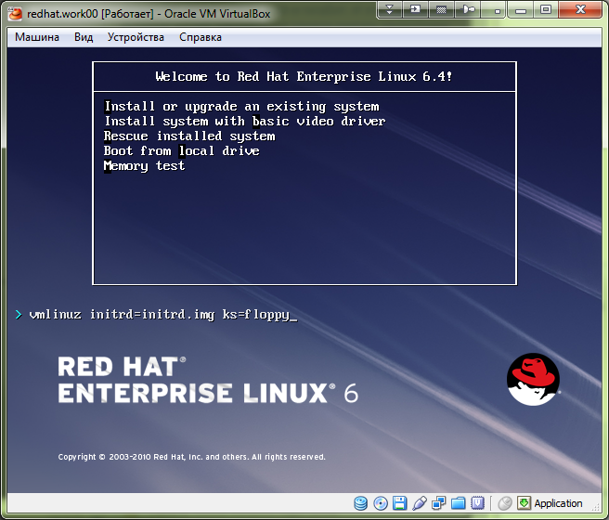

[support@centos00 kickstart]$ rm floppy.img ; mkfs.vfat -C "floppy.img" 1440 ; sudo mount -o loop -t vfat /home/support/mnt/share/greenplum/kickstart/floppy.img /mnt/floppy ; sudo cp /home/support/mnt/share/greenplum/kickstart/20140130-1629.kickstart.test.cfg /mnt/floppy/ks.cfg ; sudo umount /mnt/floppy
mkfs.vfat 3.0.9 (31 Jan 2010)
[support@centos00 kickstart]$

https://access.redhat.com/site/solutions/60959

How can we create a customized Golden Image or RHEL ISO with kickstart file?

Issue

How can we create a customized RHEL6 ISO with kickstart file included in the ISO?
Environment

Red Hat Enterprise Linux 4
Red Hat Enterprise Linux 5
Red Hat Enterprise Linux 6
Resolution

NOTE: Red Hat does not support the traditional concept of the Golden Image, instead we recommend and promote the use of kickstart to build consistent systems. Red Hat does not support the customization of installation media. This article is provided as a how-to and Red Hat will not be able to support the process described here.

1. Download the RHEL installation dvd iso or minimal boot media boot.iso

2. Mount the ISO

# mount /path/to/rhel-dvd.iso /mnt/ -o loop
3. Copy the entire contents of the disk to another location.

# mkdir /rhel
# shopt -s dotglob
# cp -ri /mnt/* /rhel
4. Create a kickstart file.

This is an example:

install
cdrom
repo --name="Red Hat Enterprise Linux" --baseurl=file:/mnt/source --cost=100
repo --name="High Availability" --baseurl=file:/mnt/source/HighAvailability --cost=1000
lang en_US.UTF-8
keyboard us
timezone --utc Asia/Shanghai
selinux --enforcing
authconfig --enableshadow --passalgo=sha512 --enablefingerprint
firewall --service=ssh
bootloader --location=mbr --driveorder=sda --append="rhgb quiet"
%packages
@base
@core
mtools
gdm
luci
%end
5. Copy the kickstart file to the /rhel directory

# cp /path/to/ks.cfg /rhel
6. Change the file '/rhel/isolinux/isolinux.cfg', change the following lines :

label linux
menu label ^Install or upgrade an existing system
menu default
kernel vmlinuz
append initrd=initrd.img
to

label linux
menu label ^Install or upgrade an existing system
menu default
kernel vmlinuz
append initrd=initrd.img ks=cdrom:/ks.cfg
7. Rebuild the DVD iso image

# cd /rhel
# mkisofs -o /tmp/new.iso -b isolinux/isolinux.bin -c isolinux/boot.cat --no-emul-boot --boot-load-size 4 --boot-info-table -J -R -V disks .
8. Boot the machine from this ISO

Kickstart has detailed documentation in the Installation Guide

Comments
Pat Larkin's picture Pat Larkin
Newbie
5 points
does it matter if i copy the ks files to /isolinux
or does it have to be root

05.04.2012
reply
Unix Support's picture Unix Support
Newbie
5 points
You'll have to change your isolinux.cfg line to

~~~
append initrd=initrd.img ks=cdrom://isolinux/ks.cfg
~~~

19.02.2013
reply
Maciej Kola's picture Maciej Kola
Newbie
15 points
I have a question about following line:

repo --name="Red Hat Enterprise Linux" --baseurl=file:/mnt/source --cost=100

In RH6.1 should it be -baseurl=file:/Packages ? or maybe /Server?

25.05.2012
reply
Miguel Perez Colino's picture Miguel Perez Colino
Red HatActive Contributor
223 points
I tried this but the ISO image did not work when dumping it, with "dd", to an USB drive.
What extra steps are needed in order to make it also USB bootable?

I reply myself:
To make the iso bootable from USB you need to make it "hybrid" by running:
isohybrid /tmp/newiso.iso
It is also very useful to implant the md5 checksum:
implantisomd5 /tmp/newiso.iso

M*

14.11.2012 - Edited
reply
Martin Klein's picture Martin Klein
Newbie
5 points
I have personally had luck using UNetbootin (http://unetbootin.sourceforge.net/) to create bootable USB drives.

01.03.2013
reply
Miguel Perez Colino's picture Miguel Perez Colino
Red HatActive Contributor
223 points
.

12.11.2013 - Edited
reply
Leon Li's picture Leon Li
Community Member
30 points
Due to our server platform didn't hvae graphic controller.so that we don't to install RHEL 6.4 x64 with GUI mode.And we want to re-build the iso file with "text and console mode" for RHEL6.4 X64. After use above process described to build a ISO image and then burn a DVD,we can't to see the UEFI DVD device to do install. but we can install "Legacy" RHEL6.4 X64 OS.Could you please give us a suggestion in isolinux.cfg? Thanks for your help.

The isolinux.cfg for "console and text mode" as below.(serial port is COMB)
default linux
prompt 0
timeout 600
display boot.msg

label linux
menu label ^Install or upgrade an existing system
menu default
kernel vmlinuz
append initrd=initrd.img ramdisk_size=8192 console=tty1 console=ttyS1,115200n8 ks=cdrom:/ks_efi.cfg

13.07.2013
reply
Leon Li's picture Leon Li
Community Member
30 points
We had make sure that BIOS can boot to UEFI and Legacy OS when attached RHEL 6.4 X64 DVD disc1.but can't boot to "custom RHEL OS image". I think it have some file or command need to change before rebuild the DVD iso image.

13.07.2013
reply
Leon Li's picture Leon Li
Community Member
30 points
We also configure the below files to do the UEFI PXE boot with "console + text mode".but It also can't boot into TEXT+Console mode after PXE boot via IPv4. but it can boot to RHEL UEFI with GUI mode.(IPv4)

Configure: efidefault,dhcpd.conf,tftf,....
option arch code 93 = unsigned integer 16;

subnet 192.168.100.0 netmask 255.255.255.0 {
range 192.168.100.100 192.168.100.120;

option subnet-mask 255.255.255.0;
next-server 192.168.100.130;

filename "pxelinux.0";
if option arch = 00:07 {
filename "bootx64.efi";
}else {
filename "pxelinux.0";
}
}

efidefault:
debug --graphics
default=0

splashimage=/EFI/BOOT/splash.xpm.gz
timeout 10

hiddenmenu
title UEFI - RHEL 6.4 x64 (TEXT)
root (nd)
kernel /images/rhel/x86_x64/6.4/vmlinuz text method=http://192.168.100.130/centos/x86_x64/6.4/ initrd /images/centos/x86_x64/6.4/initrd.img

13.07.2013
reply
Leon Li's picture Leon Li
Community Member
30 points
For above efidefault file, we also use the RHEL 6.4 x64 and CentOS 6.4 iso image to do UEFI PXE boot via IPv4.

13.07.2013
reply
David Powles's picture David Powles
Red HatGuru
21649 points
Leon, I'd encourage you to open a support case for this issue, or to raise the issue on the RHEL discussion group here: https://access.redhat.com/groups/red-hat-enterprise-linux

16.07.2013
reply
Robert Tomczyk's picture Robert Tomczyk
Newbie
17 points
Hi, I have build the DVD as described but I have problem with using it.
It's booting up fine but after I choose Language and Keyboard settings the installation DVD can't be find.

On the console I'm getting following:

Info : trying to mount CD device /dev/sr0 on /mnt/stage2
Info : drive status is CDS_DISC_OK
Info : trying to mount CD device /dev/sr0 on /mnt/stage2
Info : drive status is CDS_DISC_OK

Any idea ? I'm testing it on Vmware VM, but original DVD works fine.

08.11.2013 - Edited
reply
Robert Tomczyk's picture Robert Tomczyk
Newbie
17 points
I'm quite stuck with this one. I took original RHEL DVD, extracted it and build without any modification using the mkisofs command and still can't use it due to above problem.

11.11.2013
reply
Robert Tomczyk's picture Robert Tomczyk
Newbie
17 points
Fix it. My mistake, I wasn't copied dot files from original image

11.11.2013

[support@centos00 kickstart]$ cat 20140130-1648.kickstart.test.cfg # Kickstart file automatically generated by anaconda.

# Install OS instead of upgrade
#
#version=DEVEL
install

# Use graphical install
#
# This a default option. We can omit this and result will be same.
graphical

# I don't know what this option mean yet.
#firstboot --disable # Use CDROM installation media
#
cdrom
# This strings was gotten from GreenPlum servers. And it bring to me a lot of troubles, because if this string uncommented, during installation repositories will not be found!
# repo --name="Red Hat Enterprise Linux" --baseurl=cdrom:sr0 --cost=100

# System language
#
lang en_US.UTF-8

# System keyboard
#
keyboard us

# Network information
# # This line took from vmware virtual server installation. It has one network interface. It was a template for virtual servers.
#network --onboot yes --device eth0 --bootproto static --ip 10.217.18.218 --netmask 255.255.255.0 --gateway 10.217.18.254 --noipv6 --nameserver 10.216.42.5,10.216.40.4 --hostname rhel64-template
#
# This string is ideally for virtual server insallation under VirtualBox. I mean this guest host network works behind NAT. I use it for personal purposes.
network --bootproto=dhcp --device=eth0 --onboot=on
#
# This section have gotten from GreenPlum installed server. These are unconfigurred network interfaces. I don't know how better it should be used. It's for history.
#network --onboot no --device eth0 --noipv4 --noipv6

# Root password
#
# Here is predefined password for root user. Its name is "defoltoviy".
rootpw --iscrypted $6$33j.jZoE6xBQz08r$qL9BWtoZVoSuKJB3tY13AJLiAF8HHBBpDBFEzkqpCPOYX.rpdh4lUD0z8.wfw9hjdAU3mPD1aeklmbut1w4M2.

# Firewall configuration
#
# Here is rule of firewall iptables configuration that allow ssh connection and privent other connection. It was added than I have installed VirtualBox virtual machine.
# firewall --service=ssh
#
# Here is more prefferable string for fresh and clean server installed. It disables firewall iptables at all.
firewall --disabled

# System authorization information
#
authconfig --enableshadow --passalgo=sha512
# SELinux configuration
#
#selinux --enforcing
selinux --disabled

# System timezone
#
# Better use manual defined type of hardware BIOS clock on physical server - --utc. If server is a virtual server we may omit --utc parameter.
#timezone Europe/Moscow
timezone --utc Europe/Moscow

# System bootloader configuration
#
# For example it possible to use several of drives with predefined order. This string is an example of it. It was taken from GreenPlum servers.
#bootloader --location=mbr --driveorder=sda,sdb --append="crashkernel=auto rhgb quiet"
bootloader --location=mbr --driveorder=sda --append="crashkernel=auto rhgb quiet"

# Installation logging level
#
# This is not mandatory option. It's just for history.
logging --level=info

# Partition clearing information
#
# The following is the partition information you requested
# Note that any partitions you deleted are not expressed
# here so unless you clear all partitions first, this is
# not guaranteed to work
#clearpart --linux --drives=sda
clearpart --all

# Disk partitioning information
#
# This size is in Megabytes.
part / --fstype=ext4 --asprimary --size=5120
#part /var --fstype=ext4 --asprimary --size=40960
#part /opt --fstype=ext4 --grow --asprimary --size=200
#
# This strings have taken from GreenPlum server installation anaconda-ks.cfg file.
#
#part /boot --asprimary --fstype="ext4" --ondisk=/dev/sda --size=200
#part / --asprimary --fstype="ext4" --ondisk=/dev/sda --size=47373
#
# These strings was taken from GreenPlum servers. These strings doesn't work, it should be modified before installation.
#
# part /boot --fstype=ext4 --grow --maxsize=1008 --size=1
# part / --fstype=ext4 --size=47373
# part /data1 --fstype=xfs --size=3558262
# part /work1 --fstype=xfs --size=311848
#
# part /data2 --fstype=xfs --size=3558262
# part /work2 --fstype=xfs --size=311848
# part swap --grow --size=200

%packages
@base
@client-mgmt-tools
@console-internet
@core
@debugging
@directory-client
@hardware-monitoring
@java-platform
@large-systems
@network-file-system-client
@performance
@perl-runtime
@server-platform
@server-policy
pax
python-dmidecode
oddjob
sgpio
device-mapper-persistent-data
samba-winbind
certmonger
pam_krb5
krb5-workstation
perl-DBD-SQLite
%end
[support@centos00 kickstart]$

https://access.redhat.com/site/documentation/en-US/Red_Hat_Enterprise_Linux/6/html/Installation_Guide/s1-kickstart2-startinginstall.html

Boot CD-ROM
If the kickstart file is on a boot CD-ROM as described in Section 32.8.1, “Creating Kickstart Boot Media”, insert the CD-ROM into the system, boot the system, and enter the following command at the boot: prompt (where ks.cfg is the name of the kickstart file):
linux ks=cdrom:/ks.cfg
Other options to start a kickstart installation are as follows:

askmethod
Prompt the user to select an installation source, even if a Red Hat Enterprise Linux installation DVD is detected on the system.

asknetwork
Prompt for network configuration in the first stage of installation regardless of installation method.

autostep
Make kickstart non-interactive. Used for debugging and to generate screenshots. This option should not be used when deploying a system because it may disrupt package installation.
debug
Start up pdb immediately.

dns=<dns>
Comma separated list of nameservers to use for a network installation.

gateway=<gw>
Gateway to use for a network installation.

ip=<ip>
IP to use for a network installation, use 'dhcp' for DHCP.

ks=cdrom:/<path>
The installation program looks for the kickstart file on CD-ROM, as file <path>.

loglevel=<level>
Set the minimum level required for messages to be logged. Values for <level> are debug, info, warning, error, and critical. The default value is info.

ksdevice=<device>
The installation program uses this network device to connect to the network. You can specify the device in one of five ways:
the device name of the interface, for example, eth0
the MAC address of the interface, for example, 00:12:34:56:78:9a
the keyword link, which specifies the first interface with its link in the up state
the keyword bootif, which uses the MAC address that pxelinux set in the BOOTIF variable. Set IPAPPEND 2 in your pxelinux.cfg file to have pxelinux set the BOOTIF variable.
the keyword ibft, which uses the MAC address of the interface specified by iBFT
For example, consider a system connected to an NFS server through the eth1 device. To perform a kickstart installation on this system using a kickstart file from the NFS server, you would use the command ks=nfs:<server>:/<path> ksdevice=eth1 at the boot: prompt.

mediacheck
Activates loader code to give user option of testing integrity of install source (if an ISO-based method).

netmask=<nm>
Netmask to use for a network installation.

nofallback
If GUI fails, exit.

noipv6
Disable IPv6 networking during installation.

nomount
Don't automatically mount any installed Linux partitions in rescue mode.

nonet
Do not auto-probe network devices

noshell
Do not put a shell on tty2 during install.

repo=cdrom
Do a DVD based installation.

rescue
Run rescue environment.

syslog=<host>[:<port>]
Once installation is up and running, send log messages to the syslog process on <host>, and optionally, on port <port>. Requires the remote syslog process to accept connections (the -r option).

text
Force text mode install.

updates
Prompt for storage device containing updates (bug fixes).
updates=ftp://<path>
Image containing updates over FTP.
updates=http://<path>
Image containing updates over HTTP.
updates=https://<path>
Image containing updates over HTTPS.

upgradeany
Offer to upgrade any Linux installation detected on the system, regardless of the contents or the existence of the /etc/redhat-release file.

vnc
Enable vnc-based installation. You will need to connect to the machine using a vnc client application.
vncconnect=<host>[:<port>]
Connect to the vnc client named <host>, and optionally use port <port>.
Requires 'vnc' option to be specified as well.
vncpassword=<password>
Enable a password for the vnc connection. This will prevent someone from inadvertently connecting to the vnc-based installation.
Requires 'vnc' option to be specified as well.

https://access.redhat.com/site/solutions/331563

The physical network interface is configured even when the vlan interface only is defined in kickstart

Issue
- The vlan network interface can be configured in kickstart file from Red Hat Enterprise Linux 6.4. https://access.redhat.com/knowledge/solutions/25133
- To configure the vlan network interface only, it's configured in kickstart file. And the network kickstart command for the physical network interface is not included.
- For example, to configure the vlan interface eth0.123, the following network command is defined in the kickstart file. And, the network command for eth0 is not defined.
network --bootproto=static --device=eth0 --ip=172.31.123.6 --netmask=255.255.255.0
--gateway=172.31.123.1 --nameserver=172.31.123.1 --hostname=test.example.redhat.com
--onboot=yes --noipv6 --vlanid=123 --activate
- But, eth0 was configured unexpectedly. It got the network information from DHCP, default gateway was changed, and it failed since it could not download any rpms from the installation repository.
- Also, /root/anaconda-ks.cfg doesn't include the correct vlan information after installation.

Environment
Red Hat Enterprise Linux (RHEL) 6.4

Resolution
RHEL 6.5 / anaconda-13.21.215-1.el6 contains the fix for this issue, and is documented in the changelog:
$ rpm -q --changelog anaconda-13.21.215-1.el6 | grep -B 2 -w -e 921609 -e 903689
- Don't write vlan kickstart configuration to parent device ifcfg file
(mmatsuya)
Resolves: rhbz#903689
- Fix --vlanid option in generated kickstart file (rvykydal)
Resolves: rhbz#921609

Root Cause
There was a bug at the code to parse the kickstart file to write out the kickstart file in stage2 phase of installation. It dealt with the information defined in kickstart for the physical interface.

